2.4 Job Search Screen (Header - Arial Bold 14 pt)

Desktop View (Sub header - Arial Bold 12 pt)

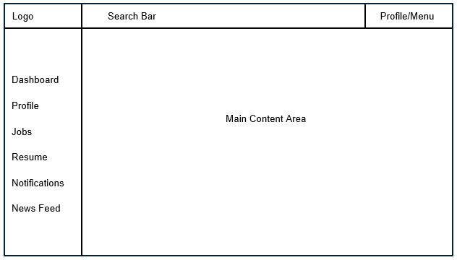
Mobile View (Sub header - Arial Bold 12 pt)

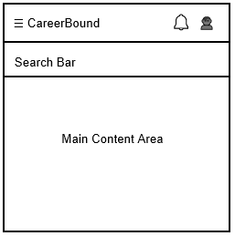 (Text in Wireframes - Arial 10 pt)

Design Information (Sub header - Arial Bold 12 pt)

Field | Description / Purpose
View Name & Number | 2.4 – Job Search Screen
Purpose / Design Concern | Allows students to search for jobs and companies.
Description | Displays searchable job listings with filters and detailed results.
Requirements | SRS 2.3 Search Features, 3.3 Student Search Features
Elements | Search bar
 | Filters
 | Results list
 | Pagination
 | Save/apply buttons
Inputs | Search terms, filter selections, wildcard search
Outputs | Matching job postings and company search results
Navigation / References | Job Details Screen, Company Profile, Student Dashboard
Viewpoint | UI Wireframe / Mockup (Desktop & Mobile)

Design Information Table Standards
- Use the Microsoft Word table style “Grid Table 4” for all design information tables.
- Tables shall span the full document text width using Preferred Width 6.5" table format.
- For header row "Repeat as header row at the top of each page"
- Elements row has each element as a separate line
- Standard document margins shall remain at 1 inch.
- Table header rows shall use Arial Bold 12 pt formatting.
- First-column field labels shall use Arial Bold 11 pt formatting.
- Table content/descriptions shall use Arial 11 pt formatting.

Wireframes
You will need to keep a copy of an editable version of your wireframe in case changes need to be made. You are welcome to turn in your wireframes individually to be approved by the Chief of Q/A before turning in the Word doc as the final deliverable to be approved by the Chief of Q/A.

Final Deliverable
The final deliverable is the Word document following the pattern shown in this document for each UI view assigned. So, since each team has been assigned 2 UI views, that means that each team will turn in 2 Word documents.

